A PROJECT REPORT ON

SKA SECURE ONLINE BANKING SYSTEM

The Word SKA Means ADEPU SAI KIRAN

DECLARATION

I hereby declare that project report titled “SKA SECURE ONLINE BANKING SYSTEM” is an original work done BY ADEPU SAI KIRAN, for the During Month April To December 2022. With the best of my knowledge and belief

Abstract

The SKA Secure Online Banking System is an application for maintaining a person's account in a bank. In this project I tried to show the working of a banking account system and cover the basic functionality of a Bank Account Management System. To develop a project for solving financial applications of a customer in banking environment in order to nurture the needs of an end banking user by providing various ways to perform banking tasks. Also, to enable the user’s workspace to have additional functionalities which are not provided under a conventional banking project. This is undertaken as a project is based on relevant technologies. The main aim of this project is to develop software for Bank Account Management System. This project has been developed to carry out the processes easily and quickly, which is not possible with the manuals systems, which are overcome by this software. This project is developed using HTML, CSS, JAVA SCRIPT, JSP and Oracle SQL use for database connection. Creating and managing requirements is a challenge of IT, systems and product development projects or indeed for any activity where you have to manage a contractual relationship. Organization needs to effectively define and manage requirements to ensure they are meeting needs of the customer, while proving compliance and staying on the schedule and within budget. The impact of a poorly expressed requirement can bring a business out of compliance or even cause injury or death. Requirements definition and management is an activity that can deliver a high, fast return on investment. The project analyses the system requirements and then comes up with the Requirements specifications. It studies other related systems and then come up with system specifications. The system is then designed in accordance with specifications to satisfy the requirements. The system design is then implemented with SQL, JSP and HTML. The system is designed as an interactive and content management system. The content management system deals with data entry, validation confirm and updating whiles the interactive system deals with system interaction with the administration and users. Thus, above features of this project will save transaction time and therefore increase the efficiency of the system.

INDEX

1. Introduction 4
2. AIM of the Project 5
3. Index/Main UI Page of Bank 6
4. What to Expect/Modules of Project 7
5. System Requirements 11
6. Software & Hardware Requirements 11
7. System Design 13
8. Project Architecture Diagram 15
9. Database Design 16
10. The Security Terms 22
11. The Bank Terms 22
12. Customer Obligations 23
13. Do’s & Don’ts 23
14. Beware of Phishing 24
15. Project Screenshots 25
16. Project Scheduling 40
17. Benefits of Online Banking 41
18. Future Look 42
19. Conclusion 44
20. References 45

INTRODUCTION

The “SKA Secure Online Banking System” project is a model Internet Banking Site. This site enables the customers to perform the basic banking transactions by sitting at their office or at homes through PC or laptop. The system provides the access to the customer to create an account, deposit/withdraw the cash from his account, also to view reports of all accounts present. The customers can access the banks website for viewing their Account details and perform the transactions on account as per their requirements. With Internet Banking, the structure of the traditional banking gets converted into a Online Banking model, thereby giving a concept of virtual banking a real shape. Thus, today's banking is no longer confined to branches. E-banking facilitates banking transactions by customers round the clock globally. Anybody who is an Account holder in this bank can become a member of Bank Account Management System. He has to fill a form with his personal details and Account Number. Bank is the place where customers feel the sense of safety for their property. In the bank, customers deposit and withdraw their money. Transaction of money also is a part where customer takes shelter of the bank. Now to keep the belief and trust of customers, there is the positive need for management of the bank, which can handle all this with comfort and ease. Smooth and efficient management affects the satisfaction of the customers and staff members, indirectly. And of course, it encourages management committee in taking some needed decision for future enhancement of the bank. Now a day’s, managing a bank is tedious job up to certain limit. So software that reduces the work is essential. Also, today’s world is a genuine computer world and is getting faster and faster day-by-day. Thus, considering above necessities, the software for bank management has become necessary which would be useful in managing the bank more efficiently. All transactions are carried out online by transferring from accounts in the same Bank or international bank. The software is meant to overcome the drawbacks of the manual system.

Synopsis

Bank Account Management System keeps the day-by-day tally record as a complete banking system. It can keep the information of Account opening form, Deposit fund, Withdrawal, Transfer Fund, Balance Enquiry

AIM of The Project

The main aim of designing and developing this Online banking System with Programming Domain of JAVA JSP (Java Server Pages) Which will run by A server Apache Tomcat, primarily based Engineering project is to provide secure and efficient net banking facilities to the banking customers over the internet. Apache Server Pages, SQL database used to develop this bank application where all banking customers can login through the secured web page by their account login id and password. Users will have all options and features in that application like get money from western union, money transfer to others, and send cash or money to inter banking as well

The Main Purpose

Main Purpose the Traditional way of maintaining details of a user in a bank was to enter the details and record them. Every time the user needs to perform some transactions he has to go to bank and perform the necessary actions, which may not be so feasible all the time. It may be a hard-hitting task for the users and the bankers too. The project gives real life understanding of How Online Banking System and activities performed by various roles in the supply chain. Here, we provide automation for banking system through Internet. Online Banking System project captures activities performed by different roles in real life banking which provides enhanced techniques for maintaining the Bank Database and Server

The Index Page of SKA SECURE ONLINE BANKING SYSTEM

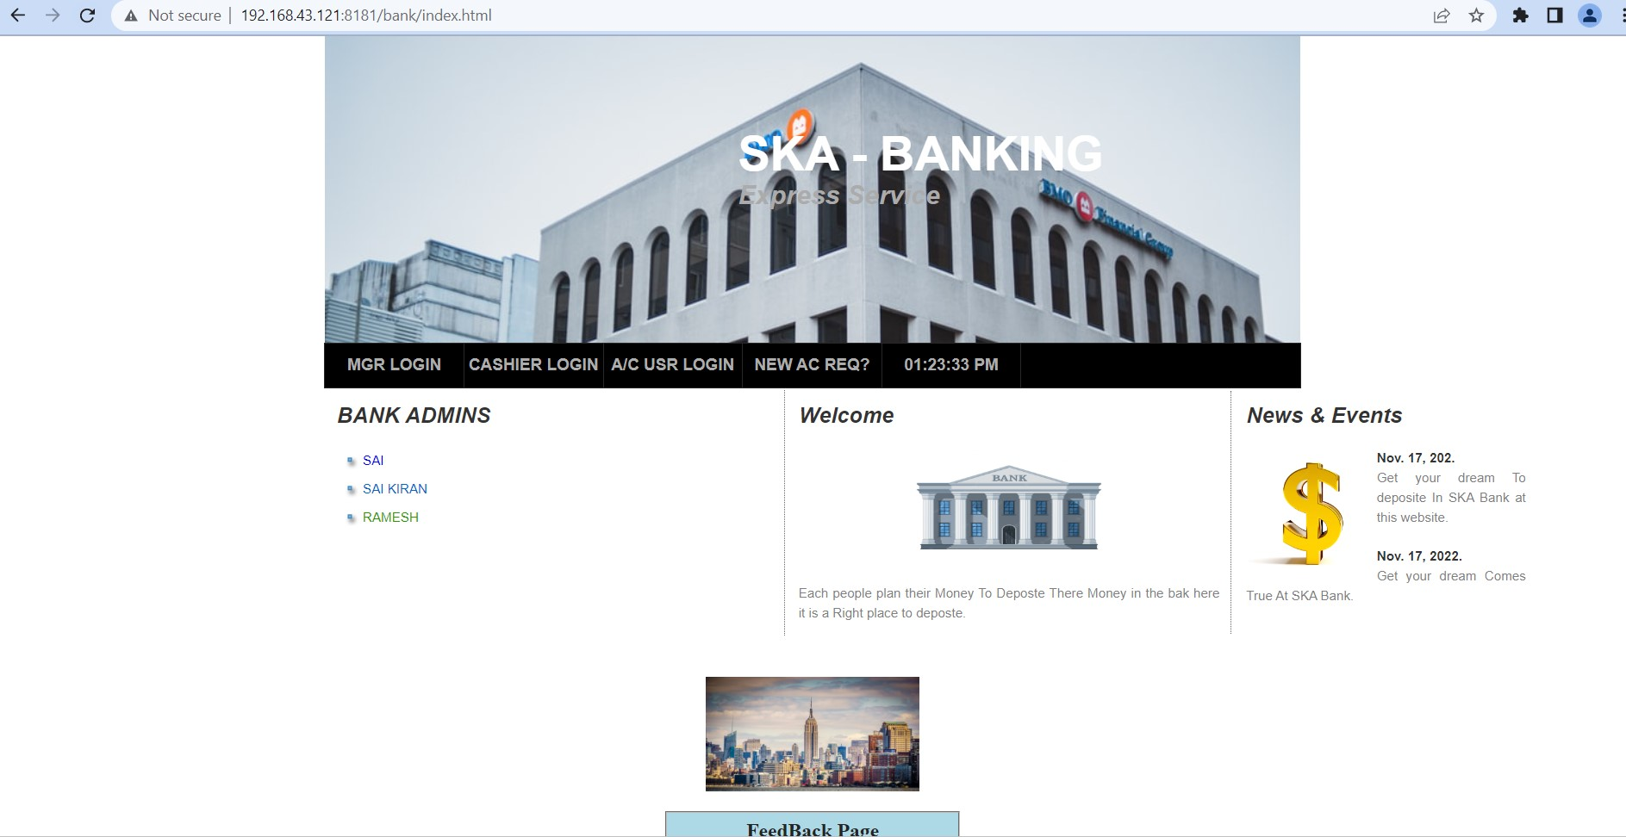

There are Mainly Four Modules

1 The Bank Manager

2 The Bank Cashier

3 The Bank A/C User

4 New Bank A/C Request

What to expect/Modules

Here are some of the features available through online banking For Manager:

1. Bank Manager: First Admin/Manager of the Bank login with user name and password with a specified credentials which will maintained by a Bank Database after a successful login Bank Manager will Perform the Following Operations

1.1 The Manager can check Total Balance in the bank

1.2 All Ac Holders in the bank

1.3 List Out of Transactions Done in Bank by A/C Holders

1.4 List Out of Transactions Done in Bank by Bank Admins

1.5 Users Feedbacks

1.6 He can do a logout the session as shown the below.

LOGIN PAGE OF BANK MANGER

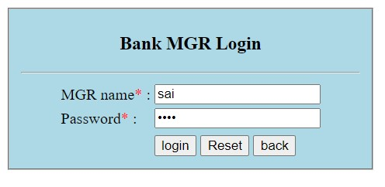

After A Successful Login Bank Manger Gets a Manager UI

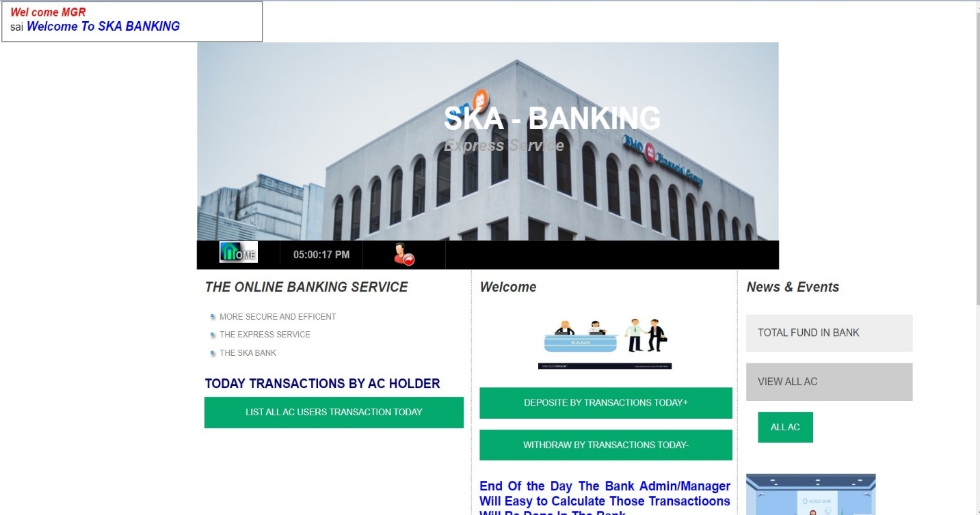

1. The Bank Admin/Cashier: First Admin/Cashier of the Bank login with user name and password with a specified credentials which will maintained by a Bank Database after a successful login Bank Cashier will Perform the Following Operations
   1. The Cahier can Check the Bank Balance
   2. Enquiry of all Account Holders
   3. A/c user Balance Enquiry
   4. User Mobile Number Modifications
   5. User Password/PIN Modification
   6. Balance Enquiry By A/C Holder Names
   7. Opening new Account for The Account Holder
   8. Deposit The Funds into Bank Database
   9. Withdrawing Funds From A/C Holders
   10. Fund Transfer from One A/C to Another A/C Holders
   11. Transaction Enquiry
   12. Closing A/C Holder in The Bank

LOGIN PAGE OF BANK CASHIER

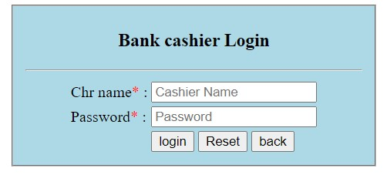

After A Successful Login Bank Cashier Gets a Cashier UI

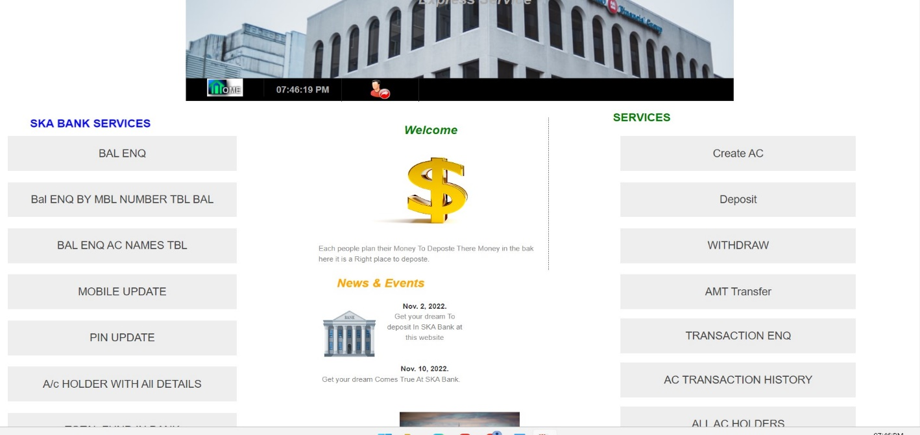

1. The Bank A/C User: A/C User of the Bank login with A/C number and password with a specified credentials which will maintained by a Bank Database after a successful login User UI will Perform the Following Operations
   1. The A/C Holder Can View the Balance in the bank
   2. The A/C Holder Can Modify his/her A/C PIN
   3. A/C Holder Can Modify the Mobile Number
   4. A/C Holder Can Transfer/Send the Fund to another’s A/C
   5. A/C Holder Can send a Fund request to another A/C
   6. A/C Holder Can See the Fund Requests From another A/C
   7. List out of Transactions in AC with Transaction Number
   8. A/C Holder Can send feedback to bank Admins
   9. A/C Holder Can Logout his/her Session on the Website

LOGIN PAGE OF A/C HOLDER

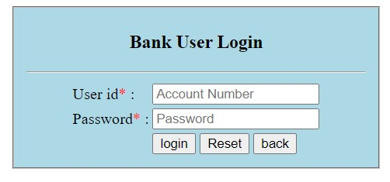

After A Successful Login Bank Gets an A/C User UI

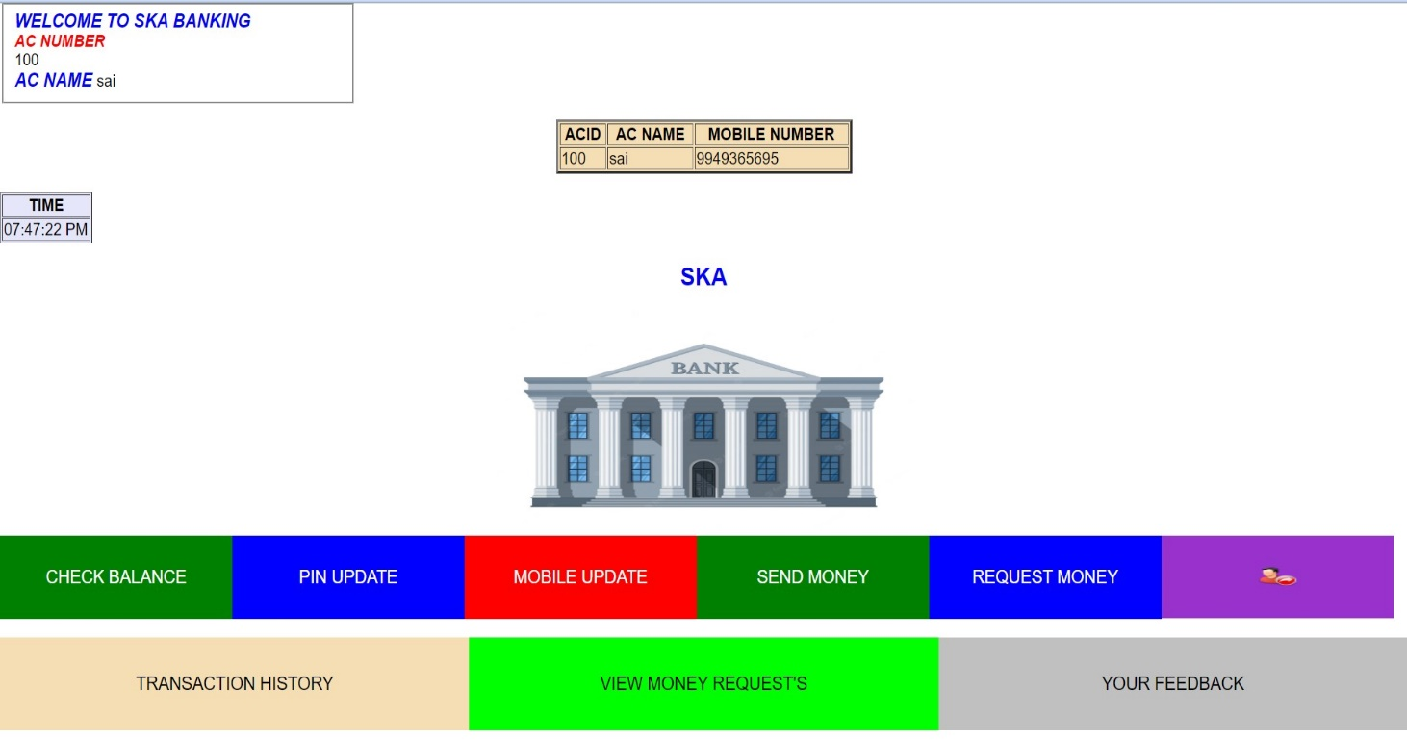



1. New Bank A/C Request: The outside of Bank Users can Request a new A/C for the bank server or Admins in the Bank

UI of New A/C Request

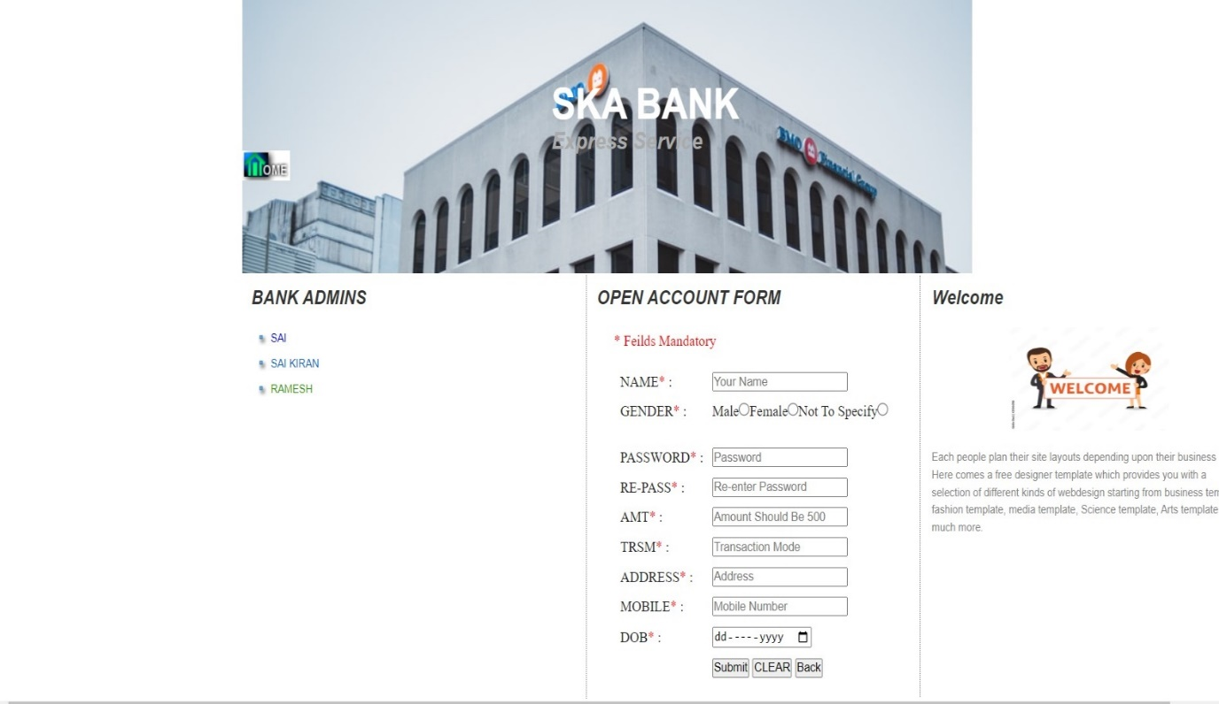

The New A/C details/credentials validated by Bank Admins

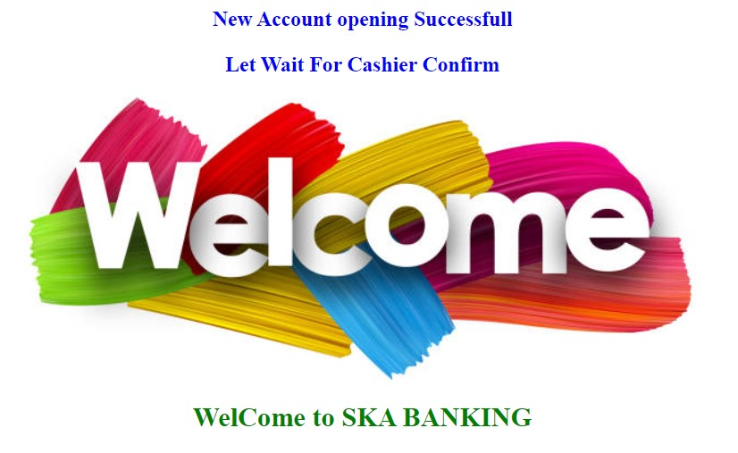

SYSTEM REQUIREMENTS

To be used efficiently, all computer software needs certain hardware components or other software resources to be present on a computer. These pre requirements are known as (computer) system requirements and are often used as a guideline as opposed to an absolute rule. Most software defines two sets of system requirements: Minimum and Recommended. With increasing demand for higher processing power and resources in newer versions of software, system requirements tend to increase over time. Industry analysts suggest that this trend plays a bigger part in driving upgrades to existing computer systems than technological advancements. A second meaning of the term of system requirements is a generalization of this first definition, giving the requirements to be met in the design of a system or sub-system.

SOFTWARE REQUIREMENTS

Front End/Language: HTML5, CSS3

Domain: JAVA, JSP

Back End/Database: SQL

Web Server: Apache Tomcat 10

Server logs: XML

Operating System: Windows 7,10,11

SOFTWARE REQUIREMENTS

Processor: Intel Core 2Duo – Later Generations i3, i5, i7

Main Memory (RAM): 4 GB

Hard Disk (Storage): 256 GB

Monitor: inch Colour Monitor

Mouse: Optical Mouse

FUNCTIONAL REQUIREMENTS

A Functional Requirements Specification describes what is required to meet the admin/users' business needs. Functional requirements specify which actions the design must provide in order to benefit the system's Admin/users. Functional requirements are determined by the needs, user, and task analysis of the current system.

* Must have valid Admin/user-id and password to login to the system.
* If a wrong password Admin/user is given thrice in succession, that Server will mark them as unauthorized persons
* It defines the function of a system or its components where function is described as a specification of behaviour between inputs and outputs.

IF an Admin/AC Holder enters wrong Credentials/Copy the direct URL of the legginged session then Server treats them as Un-Authorized Persons

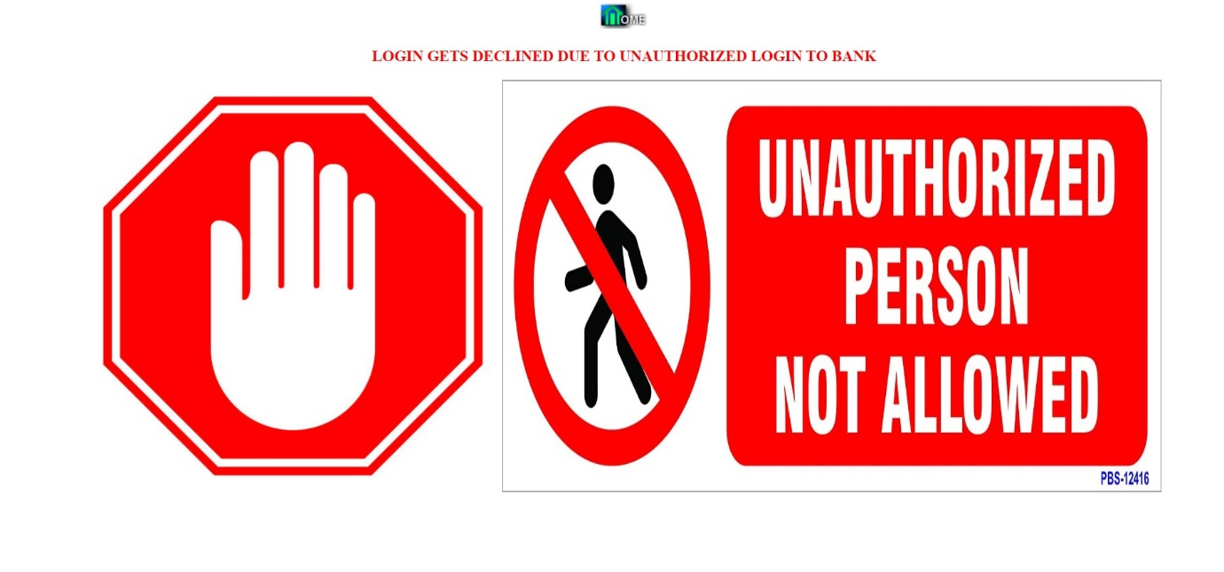

NON-FUNCTIONAL REQUIREMENTS

Non-functional requirements are requirements that are not directly concerned with the specific functions delivered by the system. ... Non-functional requirements needed in this internet banking system are identified as performance requirements, safety requirements, security requirements and software quality attributes.

* Secure for confidential data (Admin/user details)
* It is identified as performance, safety, security requirements and software quality attributes

SYSTEM DESIGN

1. Steps of System design for User in SKA banking are as follow:

* Firstly, the AC User needs to request the URL of Bank Server.
* Customer need to enter his/her credentials in the login page, then the system checks User ID and Pin No. After the system check User ID and Pin No, then the system check that this customer is valid or not.
* If it is valid, Main Menu Page of the Internet banking website. Then the customer can choose from many menus such as viewing Account Information, Funds Transfer, Payment, Update Customer Profile and so on.
* For example, if the customer chooses the Funds transfer menu, then the customer need to select Funds Transfer type such as Funds Transfer to Other A/C. Then customer needs to choose To Account and Amount. After that, submit this information to the system. And then ensure the detailed information and click Confirm button to accomplish the transaction. Key in his/her IB Secure PIN to complete this transaction After logout, customer needs to clear cache for security reason.

1. Steps of System design for Bank Admin in SKA banking are as follow:

* Firstly, the Admin to request the URL of Bank Server.
* Admin need to enter Their Credentials then the system checks Admin ID and Pin No. After the system check ID and Pin No, then the system check that this Admin is valid or not.
* If it is valid, Admin UI Menu Page of the Banking website. Then the Admin can choose from many menus such as Balance Enquiry, Modification of A/c Details like A/C PIN Modification, A/C Mobile Modification, Transfer Funds, Deposit Payment, Withdraw Fund, Services, Update Customer Profile and so on.
* For example, if the admin chooses the Funds transfer menu, then the admin needs to select Funds Transfer type such as Funds Transfer to Other A/C. Then admin needs to choose From Account, To Account and Amount. After that, submit this information to the system. And then ensure the detailed information and click Confirm button to accomplish the transaction.

System design goes through two phases of development:

1. Logical Design and
2. Physical Design.

1)Logical Design

The logical flow of a system and define the boundaries of a system. It includes the following steps:

* Reviews the current requirements of project system – its data flows, file content, volumes, frequencies etc.
* Prepares output specifications – that is, determines the format, content and frequency of reports.
* Prepares input specifications – format, content and most of the input functions.
* Prepares edit, security and control specifications.
* Specifies the implementation plan.
* Prepares a logical design walk through of the information flow, output, input, controls and implementation plan.
* Reviews benefits, costs, target dates and system constraints.

2)Physical Design

Physical system produces the working systems by define the design specifications that tell the programmers exactly what the candidate system must do. It includes the following steps.

* Design the physical system.
* Specify input and output media.
* Design the database and specify backup procedures.
* Design physical information flow through the system and a physical design Walk through.
* Plan system implementation.
* Prepare a conversion schedule and target date.
* Determine training procedures, courses and timetable.
* Devise a test and implementation plan and specify any new hardware/software.
* Update benefits, costs, and conversion date and system constraints.

SKA SECURE ONLINE BANKING SYSTEM DESIGN

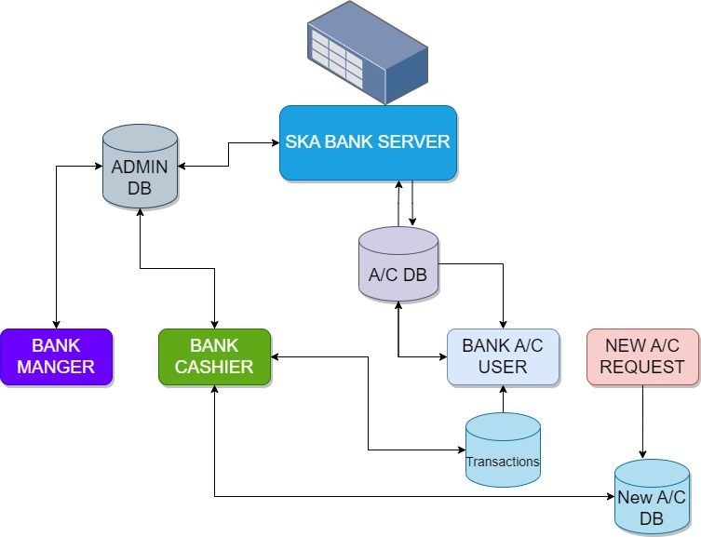

The System Design Process

* The SKA BANK Server will be a Centralised Server that keeps all Admins/users at a systematic way
* The Bank admins will be validated by the database called AdminDb if the Bank admin enters wrong credentials, then the Bank Server treated them as Un authorized admins in the bank
* And the A/C users are validated by the A/C DB if the A/c user enters the wrong credentials of then the server treated them as a un authorized persons in the Website
* The outside of the users of a bank server can Request for a new A/C and it will be manged and validated by Bank admin

Database Design

The Secure online banking database design will give the complete details of the tables that are present in the database. A bank can be defined as a financial institution which transacts its business in finance. It accepts deposits from the public and lends to those who are in need of it.

ER DIAGRAM

An entity relationship diagram (ERD) shows the relationships of entity sets stored in a database. An entity in this context is an object, a component of data. An entity set is a collection of similar entities. These entities can have attributes that define its properties. By defining the entities, their attributes, and showing the relationships between them, an ER diagram illustrates the logical structure of databases. ER diagrams are used to sketch out the design of a database.

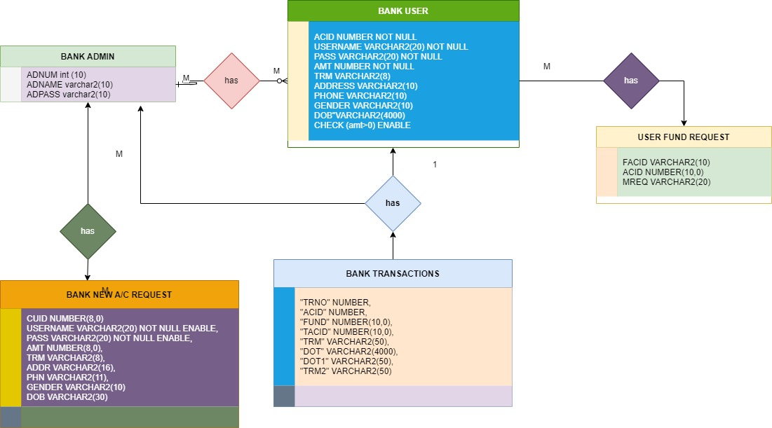

The database, called a System, will have four tables, one called Admin, Bank User, Bank New A/c Request and the other called Fund Request. Each will hold information about Admin/Ac User Name and Password The four tables will be linked through a Server. The admin table has the following fields:

1)BANK ADMIN TABLE

|  |  |
| --- | --- |
| Field | Description |
| 1. Adnum | Admin Number |
| 1. Adname | Admin Name |
| 1. Adpass | Admin Password |

2)BANK USER TABLE

|  |  |
| --- | --- |
| Field | Description |
| 1. acid | Account Number or id |
| 1. username | Name of A/C Holder |
| 1. pass | Password of A/C Holder |
| 1. Amt | Balance of Ac Holder |
| 1. trm | Mode of Transaction |
| 1. address | Address of Ac Holder |
| 1. phone | Phone number |
| 1. gender | Gender of Ac holder |
| 1. DOB | Date of Birth |

3)BANK NEW A/C USER REQUEST TABLE

|  |  |
| --- | --- |
| Filed | Description |
| 1. Cuid | A/c ID |
| 1. Username | Name of A/c Holder |
| 1. Pass | Password of A/c Holder |
| 1. Amt | Amount Money |
| 1. Trm | Mode of Transaction |
| 1. Address | Address of A/c Holder |
| 1. Phone | Phone Number |
| 1. Gender | Gender |
| 1. Dob | Date of Birth |

4)BANK USER FUND REQUEST TABLE

|  |  |
| --- | --- |
| Filed | Description |
| Facid | Request from A/c |
| Acid | Request to another A/c |
| Mreq | Request Amount |

5)BANK TRANSACTION HISTORY TABLE

|  |  |
| --- | --- |
| Filed | Description |
| TRNO | Transaction Number |
| ACID | Ac Number |
| FUND | Fund To Transfer |
| TACID | To Ac |
| TRM | Transaction Type |
| DOT | Date Of Transaction with Time |
| DOT1 | Date Of Transaction |
| TRM2 | Mode of transaction |

The Word That Associated with Above Transactions Table

* Db B -> Debited by Bank by the Bank Admins
* Cr B -> Credited by the Bank Admins
* Db A ->Debit by Bank A/C Holders While Transferring Funds
* Cb A ->Credit by Bank A/C Holders While Transferring Funds

USE CASE DIAGRAM

The purpose of use case diagram is to capture the dynamic aspect of a system. However, this definition is too generic to describe the purpose, we will look into some specific purpose, which will distinguish it from other four diagrams. Use case diagrams are used to gather the requirements of a system including internal and external influences. These requirements are mostly design requirements. Hence, when a system is analysed to gather its functionalities, use cases are prepared and actors are identified. When the initial task is complete, use case diagrams are modelled to present the outside view. In brief, the purposes of use case diagrams can be said to be as follows

* + Used to gather the requirements of a system.
  + Used to get an outside view of a system.
  + Identify the external and internal factors influencing the system.
  + Show the interaction among the requirements are actors. Online banking system has two use case diagrams: • Use case diagram for admin. • Use case diagram for user.

Use case Diagram for Bank Admin

In this Project Bank Admin divided into two types the Bank Manger and another one is Bank cashier

Use case Diagram of Bank Manager

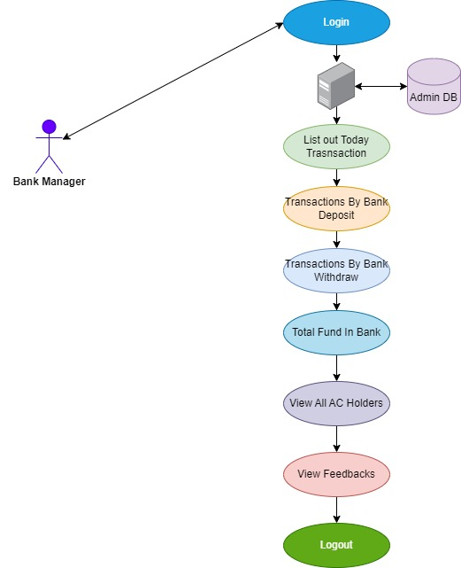

Use case Diagram for Bank Cashier

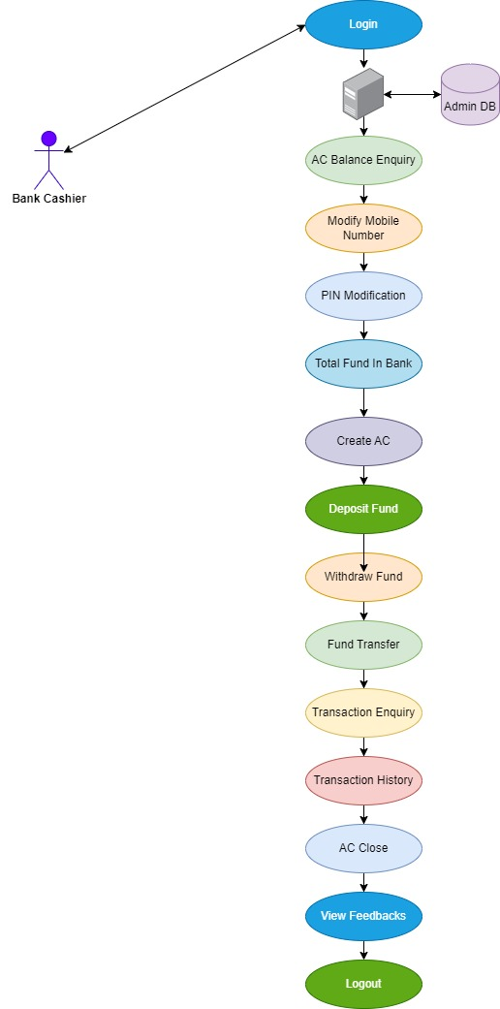

Use Case Diagram for Bank User

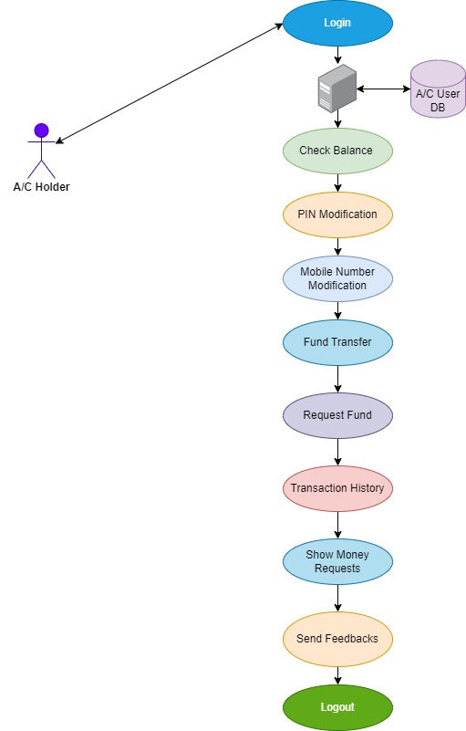

Note: If the any user/admin in the bank are with wrong credentials or enters any wrong information regarding to username password or A/c id with password then they are treated as un authorized persons in the Bank web site

Security terms

1. The Branch where the customer maintains his/her account will assign: a) User Account Number & b) Password

2. The User-id and Password given by the branch must be replaced by User Name and Password of customer’s choice at the time of first log-on. This is mandatory.

3. Bank will make reasonable use of available technology to ensure security and to prevent unauthorized access to any of this service, that it is a secure site. It means that • You are dealing with RR at that moment. • The two-way communication is secured, which ensures the confidentiality of the data during transmission.

4. You are welcome to access This Bank from anywhere anytime. However, as a matter of precaution, customers may avoid using PCs with public access.

5. There is an easy way to retrieve a password from the system. even, if a customer forgets his/her password, he/she must approach the branch Admin for re-registration.

Banks terms

1. All requests received from customers are logged for backend fulfilment and are effective from the time they are recorded at the branch.

2. Rules and regulations applicable to normal banking transactions in India will be applicable through this site.

3. The SKA Bank service cannot be claimed as a right. The bank may also convert this into a discretionary service anytime.

4. Dispute between the customer and the Bank in this service is subject to the jurisdiction of the courts in the Republic of India and governed by the laws prevailing in India.

5. The Bank reserves the right to modify the services offered or the Terms of service of SKA Bank. The changes will be notified to the customers through a notification on the Site.

Customer’s obligations

1. The customer has an obligation to maintain secrecy in regard to Username & Password registered with the Bank. The bank presupposes that login using valid Username and Password is a valid session initiated by none other than the customer.

2. Transaction executed through a valid session will be construed by Server to have emanated from the registered customer and will be binding on him/her.

3. The customer will not attempt or permit others to attempt accessing the SKA Bank through any unlawful means.

Dos & Don’ts

1. The customer should keep his/her User ID and password strictly confidential and should not divulge the same to any other person. Any loss sustained by the customer due to non-compliance of this condition will be at his/her own risk and responsibility and the Bank will not be liable for the same in any manner.

2. The customer is free to choose a password of his/her own for SKA Bank services. As a precaution a password that is generic in nature, guessable or inferable personal data such as name, address, phone number, date of birth etc. is best avoided. Similarly, it is a good practice to commit the password to memory rather than writing it down somewhere.

3. It may not be safe to leave the computer unattended during a valid session. This might give access to your account information to others.

Safe Online Banking Tips

• URL address on the address bar of your internet browser begins with "https"; the letters at the end of "https" means 'secured'.

• Look for the padlock symbol either in the address bar or the status bar (mostly in the address bar) but not within the web page display area. Verify the security certificate by clicking on the padlock.

• Do not enter login or other sensitive information in any pop-up window.

• The address bar has turned to green indicating that the site is secured with security

Beware of Phishing Attacks

• Phishing is a fraudulent attempt, usually made through email, phone calls, SMS etc seeking your personal and confidential information.

• State Bank or any of its representatives never sends you email/SMS or calls you over phone to get your personal information, password or one time SMS (high security) password.

• Any such e-mail/SMS or phone call is an attempt to fraudulently withdraw money from your account through Internet Banking. Never respond to such email/SMS or phone call.

• Change your Internet Banking password at periodical intervals.

• Always check the last log-in date and time in the post login page.

Scammers use email or text messages to try to steal your passwords, account numbers, or Social Security numbers. If they get that information, they could get access to your email, bank, or other accounts. Or they could sell your information to other scammers. Scammers launch thousands of phishing attacks like these every day — and they’re often successful.

Phishing emails and text messages often tell a story to trick you into clicking on a link or opening an attachment. You might get an unexpected email or text message that looks like it’s from a company you know or trust, like a bank or a credit card or utility company. Or maybe it’s from an online payment website or app. The message could be from a scammer, who might

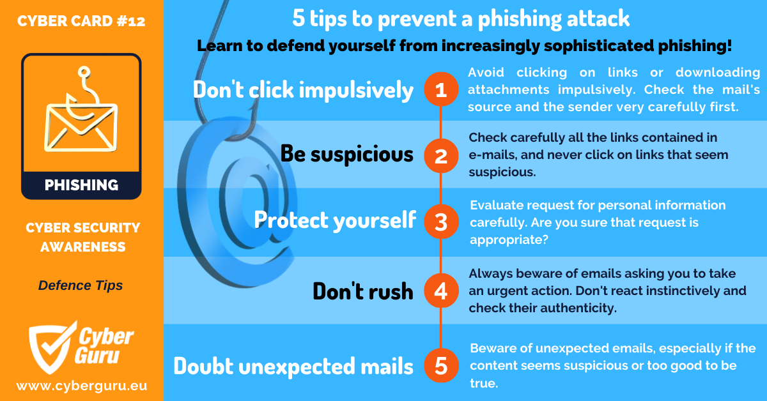

PROJECT SCREENSHOTS

* Index Page of SKA BANK

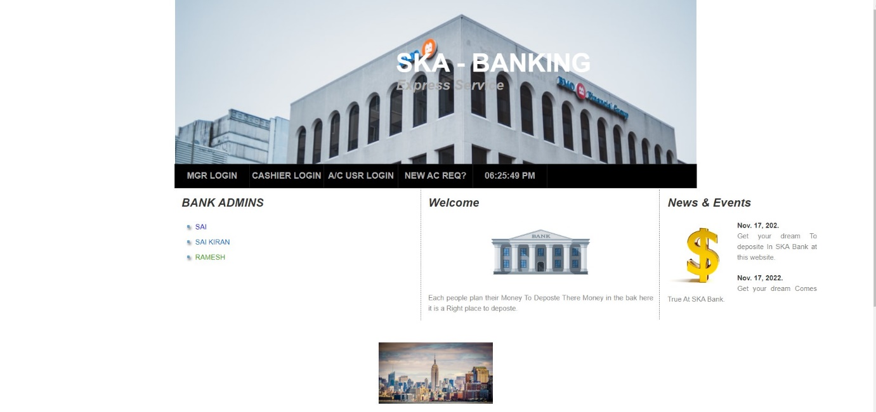

* Bank Manger Login Page

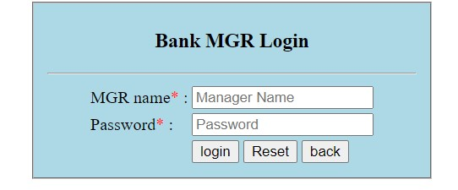

* Manager UI

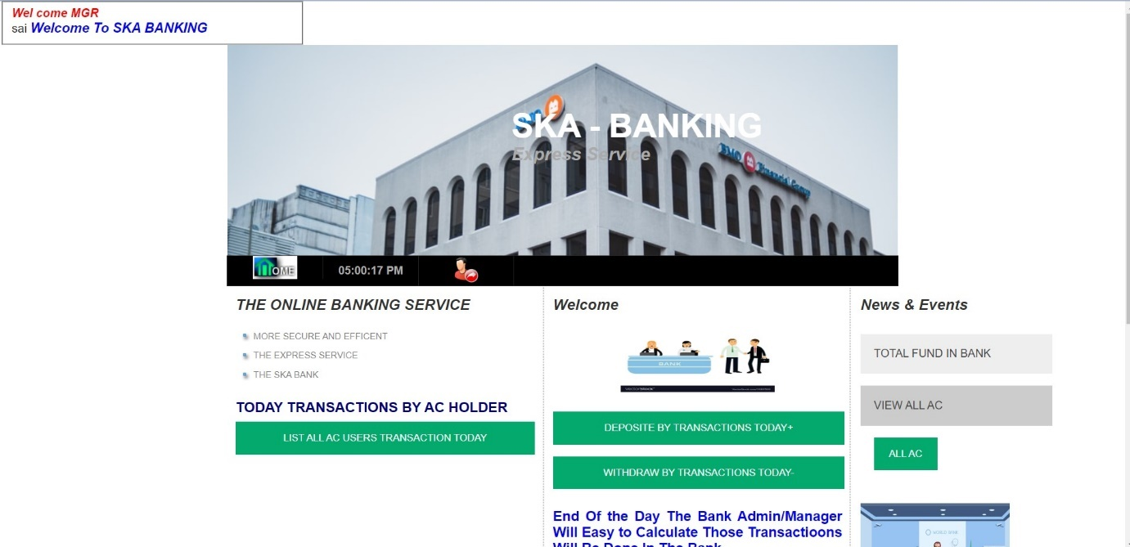

* Today’s Transactions in Bank by AC Holders

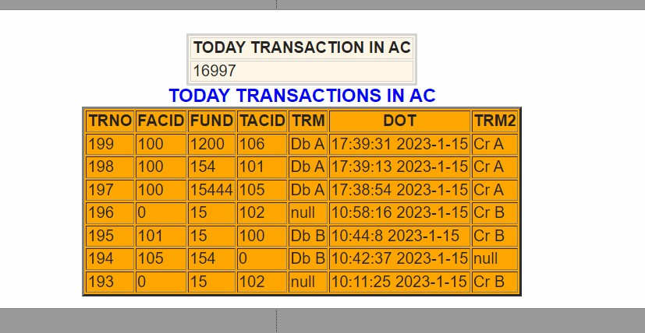

* Today’s Deposit Transactions by Bank

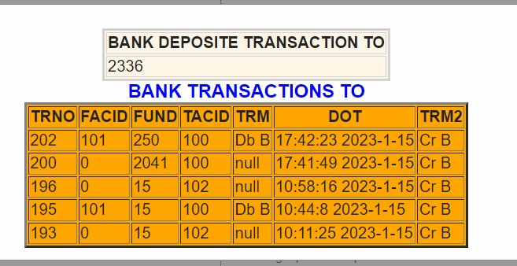

* Today’s Withdraw Transactions by Bank

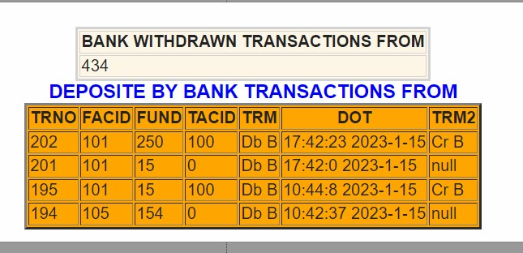

* Bank Cashier Login Page



* Bank Cashier UI

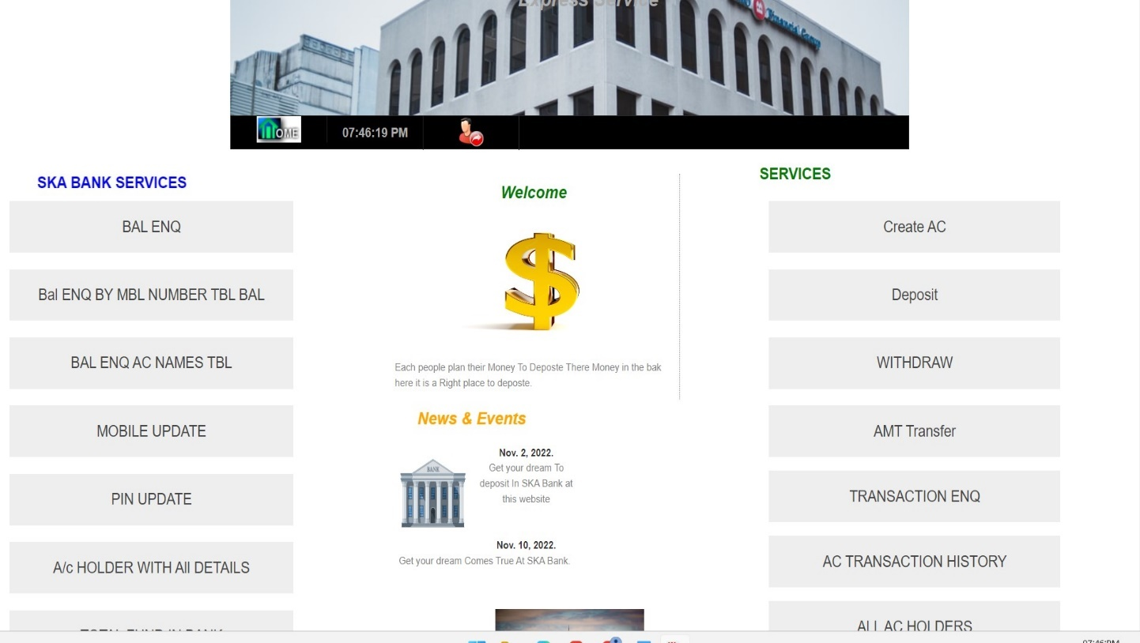

* Cashier Balance Enquiry

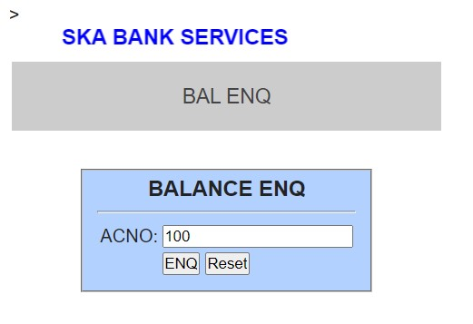

* Result of Balance Enquiry

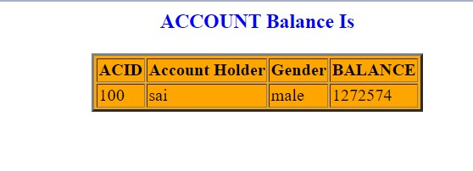

* PIN/Password Modification

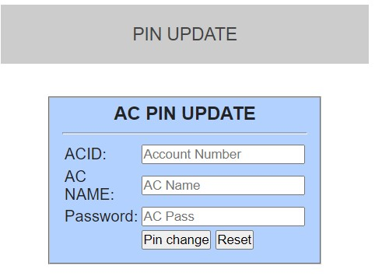

* Result of PIN Modification

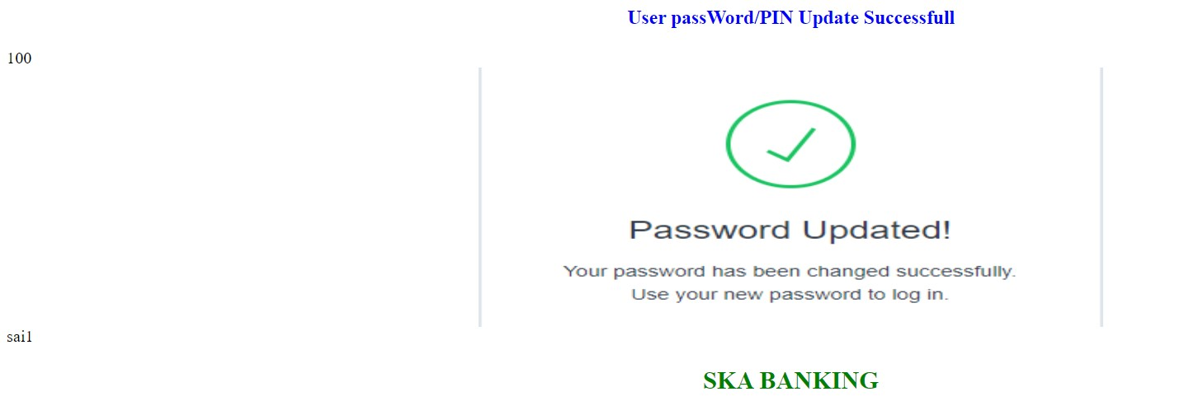

* New A/C Creation in Bank Database

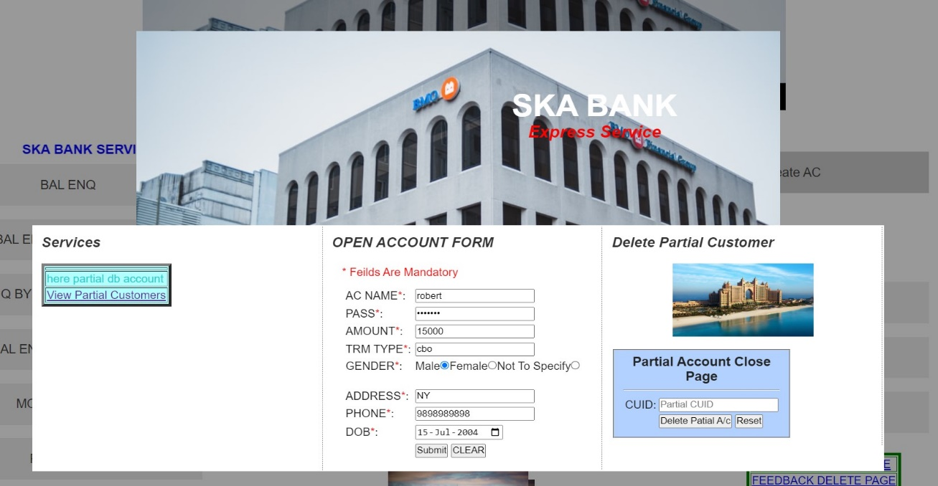

* Results of New A/C Creation



* Deposit Fund in A/C

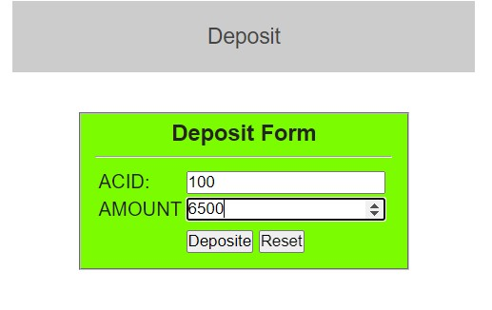

* Result of Fund Deposit

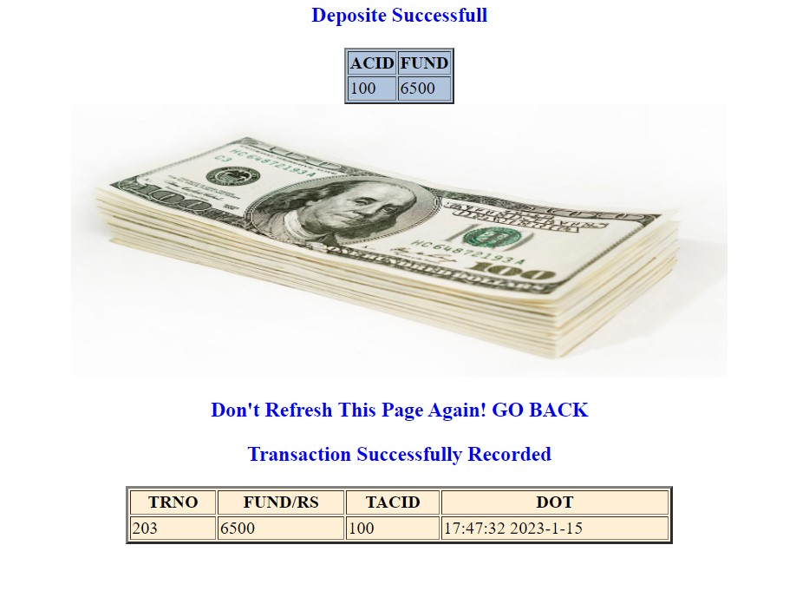

* Withdraw Fund

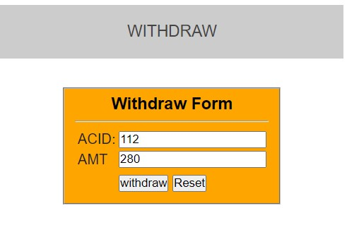

* Result of withdraw Fund

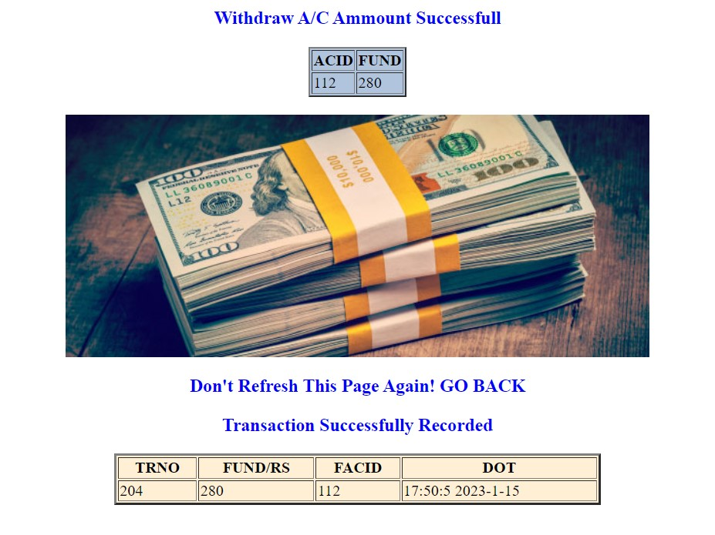

* Fund Transfer

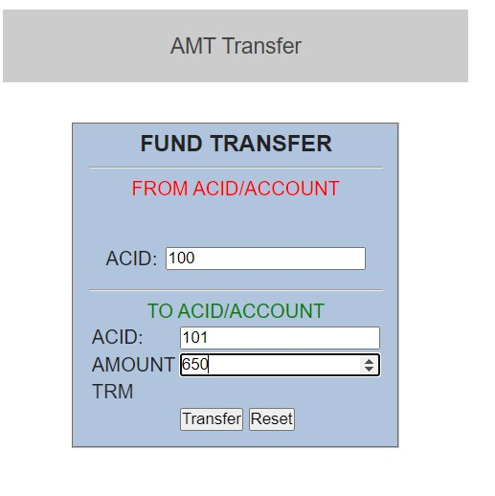

* Result of Fund Transfer

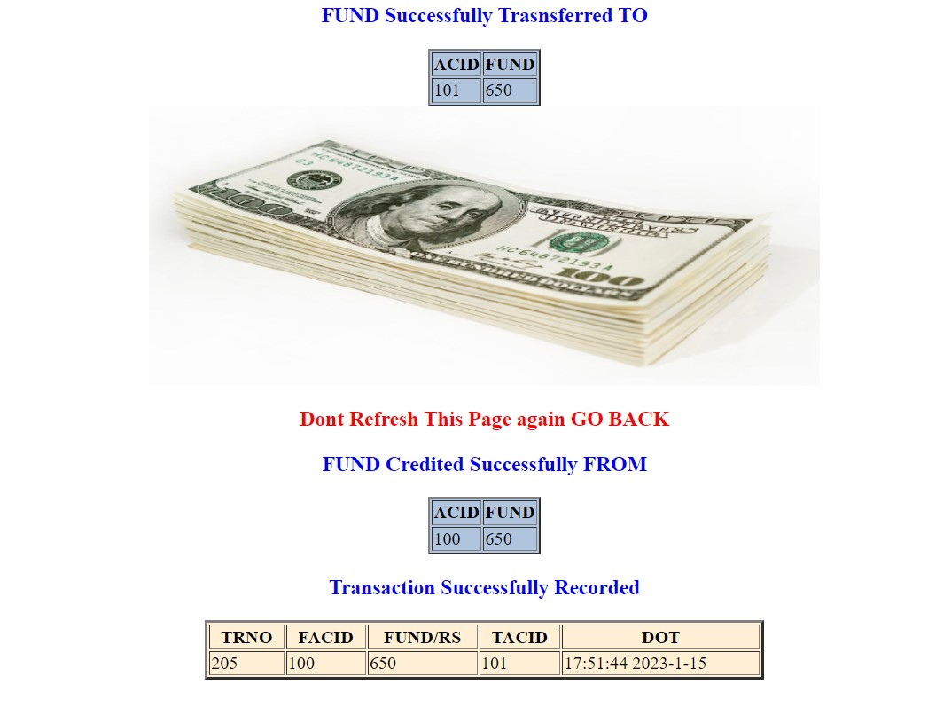

* AC Balance Transaction Enquiry

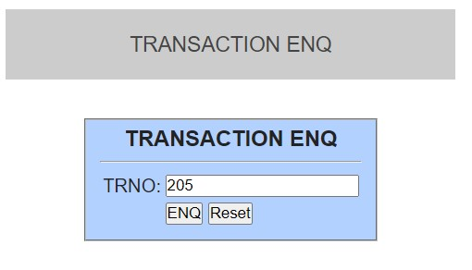

* Result of Transaction Enquiry

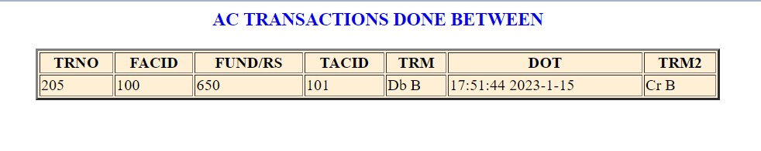

* AC Transaction Statement

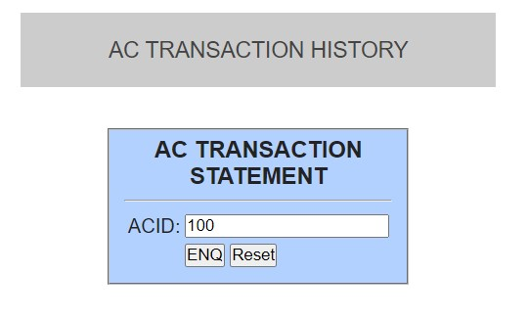

* Result of AC Transaction Statement

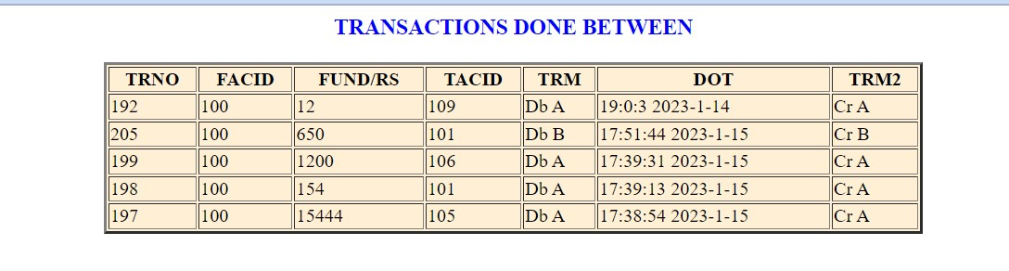

* Bank A/C User Login Page

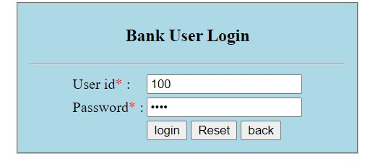

* Bank A/C User UI

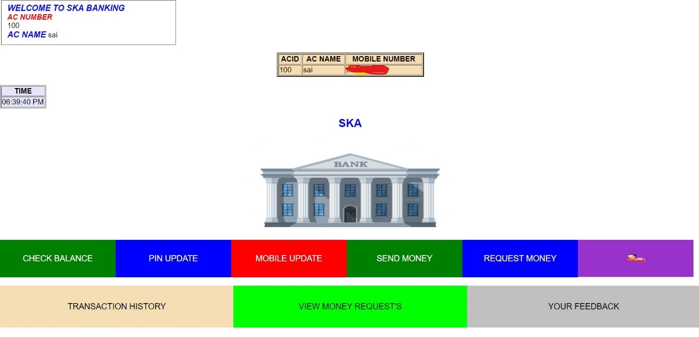



* Bank User Balance Enquiry

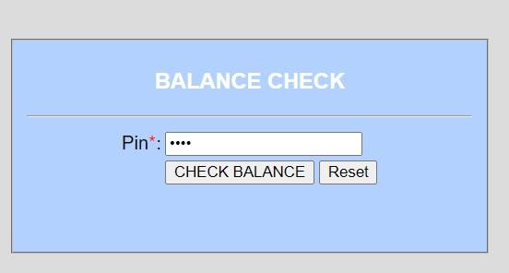

* Results of Balance Enquiry

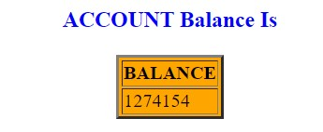

* Bank User PIN Update

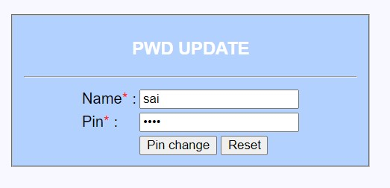

* Results PIN Update

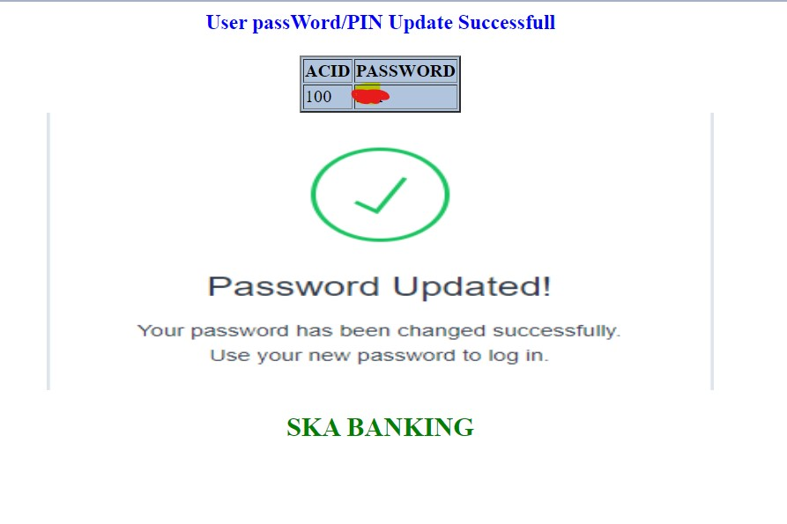

* Bank User Fund Transfer

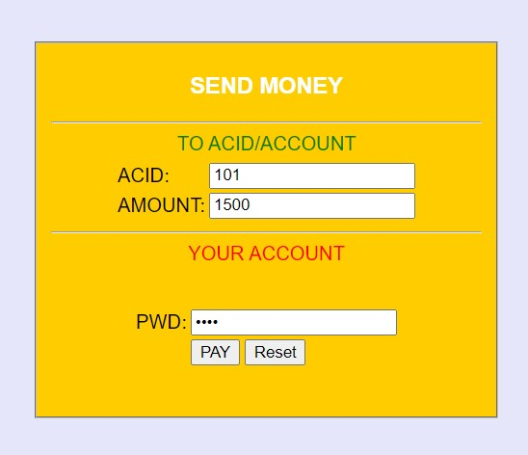

* Result of Bank User Fund Transfer

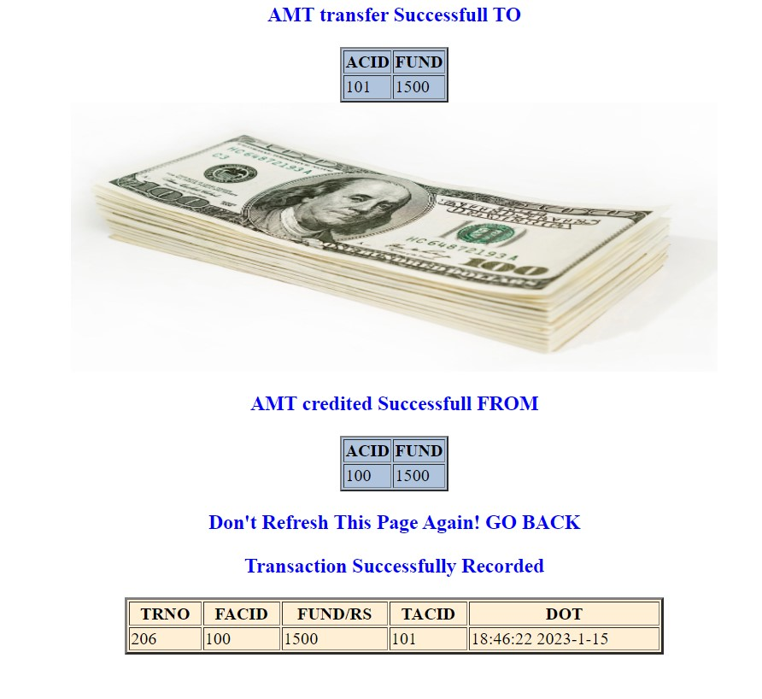

* When Bank User Transfers Fund That not exist in his/her Bank AC

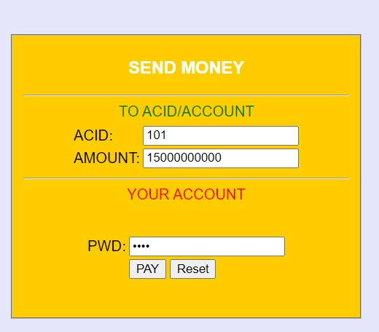

* Results of not Amount Exist Bank

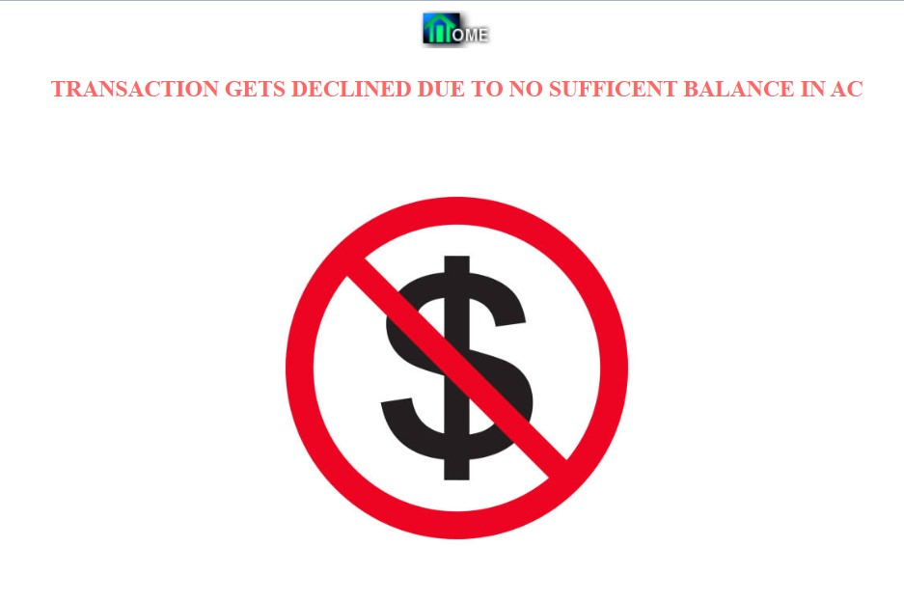

* Bank User Fund Request

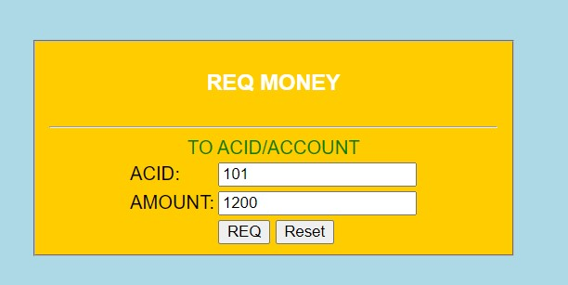

* Results of fund request



* And the Amount Requests will be shows when A/C holder Logins in his/her UI as Shown below

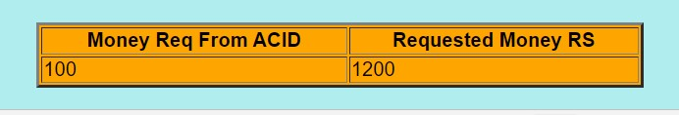

* Bank User for Feedback

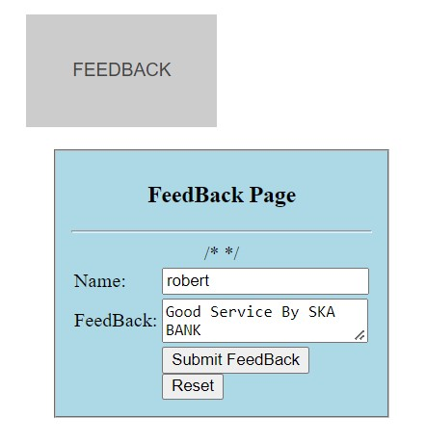

* Result of Feedback

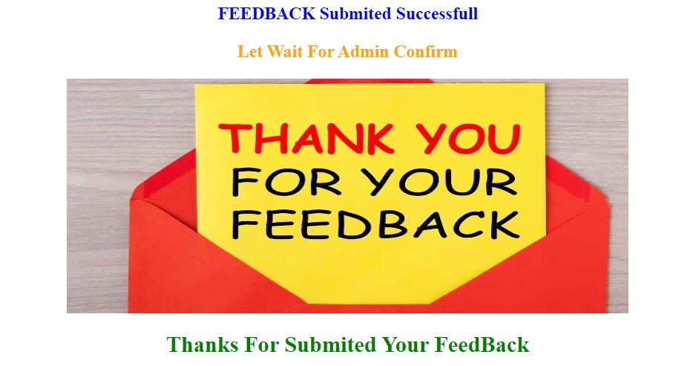

* After all User can logout his/her Session as shown below



PROJECT SCHEDULING

I estimate time and resources of this Secure Online Banking System project while scheduling project. All activities in project must be arranged in a coherent sequence that means activities should be arranged in a logical and well-organized manner for easy to understand. Initial estimates of project can be made optimistically which means estimates can be made when all favourable things will happen and no threats or problems take place.

|  |  |  |  |  |  |  |
| --- | --- | --- | --- | --- | --- | --- |
| Months | AUG | SEP | OCT | NOV | DEC | JAN |
| Information Gathering |  |  |  |  |  |  |
| Requirements Gathering |  |  |  |  |  |  |
| Planning |  |  |  |  |  |  |
| Analysis |  |  |  |  |  |  |
| Design |  |  |  |  |  |  |
| Coding |  |  |  |  |  |  |
| Testing |  |  |  |  |  |  |
| Implementation |  |  |  |  |  |  |
| Documentation |  |  |  |  |  |  |

Benefits of online banking

Many of us lead busy lives. Some of us are up before the crack of dawn, getting ourselves prepared so we can in turn get our families ready for the day. We rush to work, rush to get the kids to school, and at the end of the day we rush home only to brace ourselves for the next day. After a hectic day, the last thing you want to do is spend time waiting in line at the bank, or even the post office. That's where Online Banking comes in. Many of the benefits of doing our banking online are obvious:

* You don't have to wait in line.
* You don't have to plan your day around the bank's hours.
* You can look at your balance whenever you want, not just when you get a statement.

There are some hidden benefits too. As a young bank customer, you're just learning how to manage your money and observe your spending patterns.

* Online banking allows you to watch your money on a daily basis if you want to. By keeping close tabs on your funds, you'll always be aware of what's happening in your bank account.
* For those experienced spenders, this option is far more appealing than the sudden discovery that you're broke!
* It's also helpful to watch how much interest you're gathering on investments and savings or what service charges you have incurred.

Future Look

The “SKA Online Banking System is a big and ambitious project. I am thankful for being provided this great opportunity to work on it. As already mentioned, this project has gone through extensive research work. On the basis of the research work, I have successfully designed and implemented banking online System. To know what the future of online banking looks like, it’s probably worth looking at the present – online banking isn’t new. When you think of online banking, you probably think about a computer (either a desktop or laptop), a three or four step security process and then an interface that lets you view the balance of your various bank accounts and credit cards, wish list permitting you to transfer money and pay bills. And you’re not wrong either.

This project was developed to fulfil user requirement; however, there are lots of scope to improve the performance of the Online Banking System in the area of user interface, database performance, and query processing time. Etc. So there are many things for future enhancement of this project. The future enhancements that are possible in the project are as follows

We live in an era of online and digital banking. Online banking has made transactions easy, convenient and hassle-free. You can conduct various transactions using the bank's website. It also offers several other advantages. Online Banking not only provides you with ease of transactions and greater accessibility but also offers you a host of other advantages. Here are five advantages of Online Banking that you should know-

* You can easily open an Online bank account. They are extremely simple to operate, and you can use it for various purposes that include paying your bills, transferring funds between multiple accounts, etc. Thus, making payments faster. Online Banking can also help you view your transactions comprehensively and keep a record.
* You can perform your tasks from anywhere and at any time; even in the night when the bank is closed or on bank or public holidays. The only thing you need to have is an active internet connection, and you can easily transact 24*7, 365 days!
* It is fast and efficient. Your funds get transferred from one account to the other very fast and without any hassle. You can also manage several accounts efficiently through internet banking.
* You can keep a watch on your daily transactions and account balance at all times. This facility also helps keep your account safe. You can also get to know about any fraudulent activity or threat to your account much before it can pose your account to severe damage, immediately, within a matter of minutes.
* You can stay updated about your bank’s products like loans, investment options, etc. Plus, you can avail a lot of offers on shopping and purchases and a range of other services that can help you get more for less.
* More branches of the bank, maybe it will be international, that means more ATM machines outside.
* Customer issues development based on their needs, so the help desk will be aware of their needs and easy to use.
* Developing a mobile App for banking system that help users to do the obtained his operations without go to the bank only he needs to sign in using his A/C NO. And password and then use your own PIN. Finally, the system will update automatically

• Integration with other bank and government agencies through Web Services • Connection to third-party OLAP applications

• Electronic Data Interchange (EDI) system for ATM machine

• Web Interface for net banking.

• In the area of data security and system security.

• Provide more online tips and help.

Conclusion

This project is developed to nurture the needs of a user in a banking sector by embedding all the tasks of transactions taking place in a bank. Future version of this project will still be much enhanced than the current version. Writing and depositing checks are perhaps the most fundamental ways to move money in and out of a checking account, but advancements in technology have added ATM and debit card transactions. All banks have rules about how long it takes to access your deposits, how many debit card transactions you're allowed in a day, and how much cash you can withdraw from an ATM. Access to the balance in your checking account can also be limited by businesses that place holds on your funds. Banks are providing internet banking services also so that the customers can be attracted. By asking the bank employs we came to know that maximum numbers of internet bank account holders are youth and business man. Online banking is an innovative tool that is fast becoming a necessity. It is a successful strategic weapon for banks to remain profitable in a volatile and competitive marketplace of today. If proper training should be given to customer by the bank employs to open an account will be beneficial secondly the website should be made friendlier from where the first-time customers can directly make and access their accounts. Thus, the Bank Management System it is developed and executed successfully.

Reference

Learning MYSQL, JavaScript, jQuery, PHP, HTML, CSS3, Website: <http://www.w3schools.com>

JavaScript validation for empty input field, (May 10, 2015) Website: <http://stackoverflow.com/questions>

Online UML Diagrams <https://app.diagrams.net/?libs=general;er>

Validating SQL Commands for Fund Transactions <https://www.geeksforgeeks.org/how-to-validate-sql-query-with-regular-expression/>

Inserting Dates to Database <https://stackoverflow.com/questions/39032973/inserting-date-field-into-database-using-jsp-with-different-date-formats>

Tomcat Custom Page Redirection for Internal Server Error 500 <https://stackoverflow.com/questions/39032973/inserting-date-field-into-database-using-jsp-with-different-date-formats>

Article on Beware of Online Phishing Sites/E-mails <https://consumer.ftc.gov/articles/how-recognize-and-avoid-phishing-scams>

THE-END